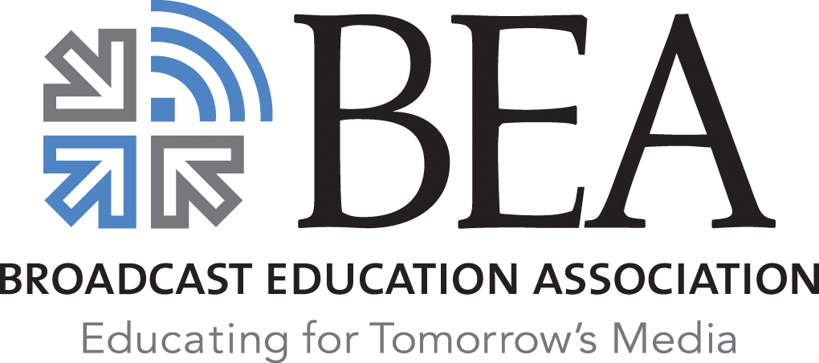

2022-2023

BEA Scholarships in Broadcasting & Electronic Media

The Broadcast Education Association is the premiere international academic media organization, promoting insights, excellence in media production, and career advancement for educators, students, and professionals. BEA administers scholarships annually, to honor broadcasters and the entire electronic media profession. The BEA Founders Awards are for students enrolled in a BEA 2-Year member institution or graduates of these programs now enrolled in a BEA 4-Year institution. All other scholarships are awarded to juniors, seniors and graduate students at BEA member institutions.

For study in ANY electronic MEDIA area…
BEA FOUNDERS AWARD
Two scholarships; $1,500 each | Sponsored by BEA
Preference given to students enrolled in a BEA 2-Year member institution or graduates of 2-Year schools now enrolled in a BEA 4-Year institution
Peter B. Orlik AWARD
One scholarship; $3,500 | Sponsored by the Peter B. Orlik Scholarship Endowment

RICHARD EATON FOUNDATION AWARD
One scholarship; $4,000 | Sponsored by the Richard Eaton Foundation

VINCENT T. WASILEWSKI AWARD
One scholarship; $4,000 | Sponsored by Patrick Communications, LLC
*Graduate students only

Edward o. Fritts Scholarship AWARD
One scholarship; $1,000 | Sponsored by Eddie Fritts Scholarship Endowment

For study toward a career in RADIO…
ABE VORON AWARD
Three scholarships; $3,000 each | Sponsored by the Abe Voron Committee

JOHN BAYLISS AWARD
One scholarship; $3,500 | Sponsored by the John Bayliss Foundation

For research interest in BROADCAST HISTORY…
LIBRARY OF AMERICAN BROADCASTING FOUNDATION AWARD
One scholarship; $3,000 | Sponsored by the Library of American Broadcasting Foundation *Graduate students only focusing on broadcast history

Criteria For Selection:
The applicant should be able to show substantial evidence of superior academic performance and potential to become an outstanding electronic media professional. There should be compelling evidence that the applicant possesses high integrity and a well-articulated sense of personal and professional responsibility.

Application Procedures:
Visit www.beaweb.org for scholarship criteria, directions & application. The application MUST be typed to be considered. Keep an additional copy for your files. Remember to date and sign the form on the last page. Applications not typed and signed will be disqualified. Each copy of the application MUST be collated and securely stapled. The application asks for personal and academic data and transcripts, media and other experience, a written statement of goals, and supportive statements from two references, at least one of which must be an electronic media faculty member. Both must be submitted on the reference's letterhead. Scholarships will be awarded for full-time degree work FOR THE FULL ACADEMIC YEAR. One semester grants are NOT provided. Scholarships must be used exclusively for tuition, student fees, university bookstore course purchases, dormitory and related items eligible to be charged to a student's official campus account. Current scholarship holders are not eligible to reapply in the year following their award.

All scholarships must be applied to study at a campus where at least one department is a BEA institutional member. Go to www.beaweb.org and click on Scholarships to check if a campus is an institutional member or call (202) 602-0587.

Summary:
Submit FOUR completed copies of the application. Each copy should include, in order:
- Typed Application Form
- Transcript(s) from all collegiate institutions
- TWO Letters of Recommendation
- Thesis or dissertation proposal abstract (If applying for the LAB Scholarship)

Mail Materials Directly To:
Dr. Peter B. Orlik
BEA Scholarship Committee Chair
613 Kane Street
Mt. Pleasant, MI 48858

All materials MUST be received by close of business on:
OCTOBER 16, 2021

DO NOT send disk, tapes, resumes, photos, etc. NO faxed or emailed materials will be accepted. Only send materials that are requested. No other materials will be considered by the Scholarship Committee. Incomplete applications will be disqualified. DO NOT mail any materials to BEA Headquarters. BEA is unable to pursue missing or lost items.

If you have questions regarding the application preparation or submission please email Dr. Orlik directly at orlik1pb@cmich.edu. Due to the large volume of scholarship related business, phone calls cannot be returned.

