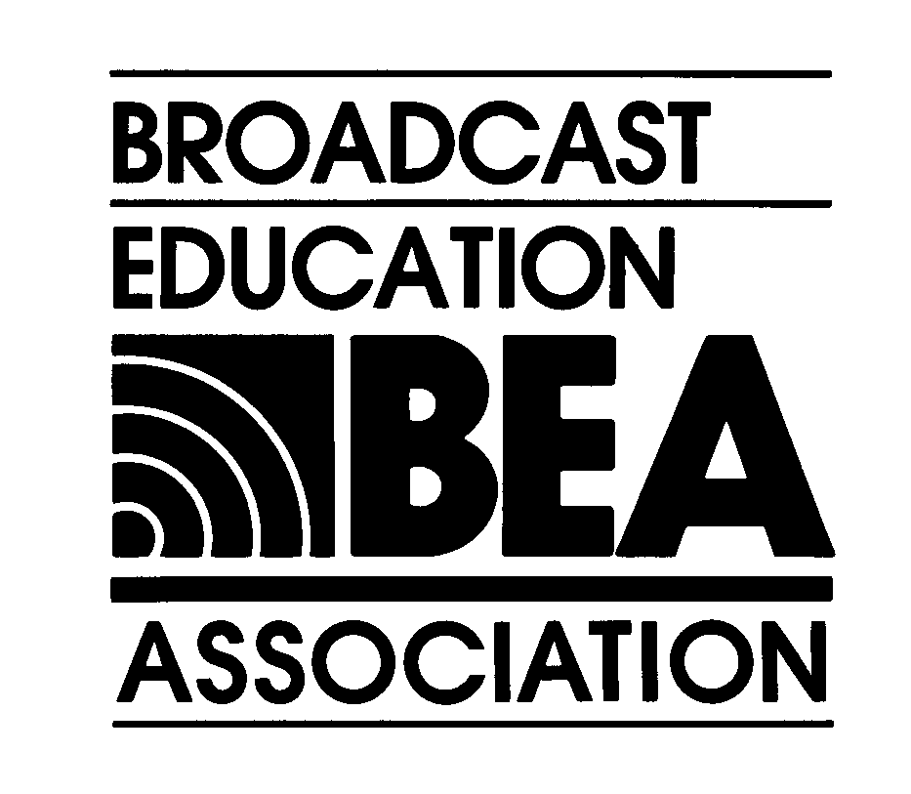

BROADCAST EDUCATION ASSOCIATION

50th ANNIVERSARY ANNUAL CONVENTION, EXHIBITION

& MEDIA ARTS FESTIVAL

Las Vegas, Nevada April 21 - 23, 2005

Advertising, Exhibit, Sponsorship, Mail List

APPLICATION AND CONTRACT

Date: _________________________
To: Broadcast Education Association Attention: Louisa A. Nielsen, BEA Executive Director
1771 N Street, NW Telephone: 202-429-3935, Washington, DC
Washington, DC 20036-2891 Fax: 202-775-2981
USA E-mail: lnielsen@nab.org Web: www.beaweb.org
Please Respond Promptly.
FINAL EXHIBIT AND ADVERTISING SPACE RESERVATION DUE: February 18, 2005.
Audio-Visual, Food and Beverage, and Signage Orders due February 25, 2005
Convention related orders must be sent with full payment. The deadline for payment is Friday, February 18, 2005, COB, ET. BEA will not go to print with an advertisement or plan to place an exhibitor or announce a sponsor unless the order is placed with full payment. Thank you.

 | Please mark your selections below
Program Advertising |  |  | Exhibit Fee Information |  | Sponsorships
__$300, Full Page Ad  __$200, Half Page Ad  __$800, Cover 2  __$800, Cover 3  __$1,000, Cover 1  __$1,000, Cover 4  __$300, Inserts |  |  | __$1,100, 22’x10’ Booth  (3 tables)  __$900, 18’x10’ Booth  (2 tables)  __$700, 10’x10’ Booth  (1 table)  SPACE PREFERENCE:  Please specify booth numbers for your choices of exhibit space in order of preference. |  | __$800, Coffee Break  __$400, Cookies with coffee break  __$3,000, Opening Continental Breakfast  __$10,000, Opening Night Reception  __$25,000, Premier Audio Visual Campaign
1.__________ 2. __________ 3. __________ 4. __________
We prefer to have our exhibit located near (list companies)________________________________________________
We prefer to have our exhibit located away from ________________________________________________________
++++++++++++++++++++++++++++++++++++++++++++++++++++++++++++++++++++++++++++++++++++++++++++++++++++
Also Available: Non-Members BEA Member Mailing Labels
__$100, Institutional Mail Labels “One Time Only Rental” __$50, Institutional Mail Labels
__$100, Individual Mail Labels “One Time Only Rental” __$50, Individual Mail Labels

Sub Total: $_______________ $__________________ $________________________
TOTAL AMOUNT OWED: $________________________________________

Please complete and submit the information below and return with your payment:

Contact Name:_________________________________________________________________________________

Company Name:________________________________________________________________________________

Address:______________________________________________________________________________________

City, State, Zip:_________________________________________________________________________________

Phone:___________________________Fax:__________________________Email:__________________________
I authorize BEA to charge $ to my:
METHOD OF PAYMENT: (please check one) ___Check enclosed, #__________ ____VISA ____MC ____AMEX

CC#:_____________________ Expiration Date:__________________ Print Name on Card:_________________________

Authorized Signature (required):_____________________________________________________________________
RETURN THIS FORM, WITH PAYMENT, TO: BEA, 1771 N Street, NW, Washington, DC, 20036-2981.
If paying by credit card, you may fax this form to: Attn: Louisa Nielsen: 202-775-2981. Thank you.
Visit: www.beaweb.org for all BEA 2005 convention information.

