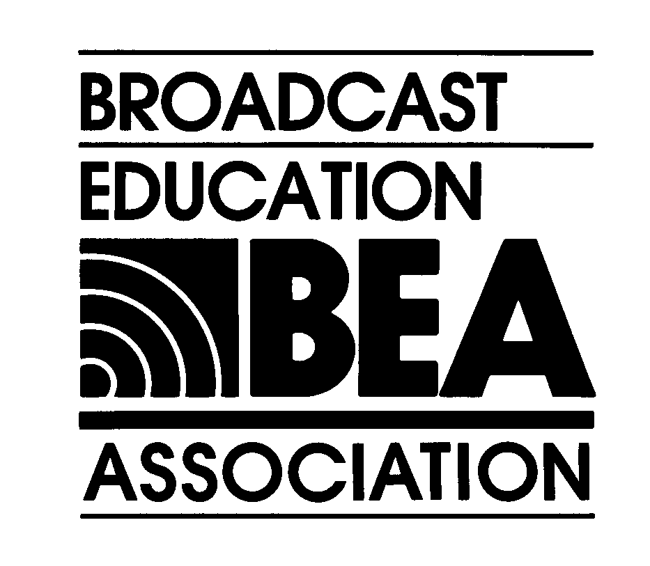

Theme: BEA2004: Bold Vision, Fresh Thinking

BEA’s 49th Annual Convention & Exhibition
BEA’s 2nd Annual Media Arts Festival
April 16-18, 2004 * Las Vegas, Nevada * www.beaweb.org

Official
BEA Convention Program Session
Proposal Form

***
The DEADLINE for
Submission of this Form
TO the BEA Interest Divisions Chairs,
for Proposed Panels, Workshops, Demonstrations, etc., is

Friday, August 8, 2003

***

1. Session Proposal submitted to (Name of BEA Interest Division):

2. Co-Sponsorship of Session Solicited? Yes No

If yes, Co-Sponsor BEA Interest Division(s): _____________________________________________
If soliciting co-sponsorship, send a copy of this completed form to the Chair of each Interest Division that you wish to co-sponsor this session.
Each Interest Division must submit this form separately for the session to be considered a co-sponsored program.

3. Person submitting proposal: _____________________________________________

4. Mailing Address: _______________________________________________________

______________________________________________________________________

______________________________________________________________________

5. Phone: _________________________ Extension: ___________

6. Fax: ____________________________

7. Email: _______________________________________________

- Title of session,etc.: _________________________________________________________

9. Session Type (Check one):

Invited Panel Session
Competitive Paper Session
Showcase
Workshop
Technical Demonstration
Other ________________

10. Abstract of Session, Workshop, etc. : (50-75 words)

________________________________________________________________________________________________________________________________________________

11. If you are proposing a Workshop, what are the specific learning objectives of the Session(s)?

________________________________________________________________________________________________________________________________________________________________

12. Moderator's Name: _____________________________________________
13. Institution: ____________________________________________________

14. Phone:___________________________________
- Fax: _____________________
- Email: ______________________________

- Panelists/participants:

 | Name | Institution | Presentation Title
1.
2.
3.
4.
5.

- Respondent, if applicable (Name and institution):___________________________________

19. AUDIO VISUAL INFORMATION:

a. All Regular Session Rooms will be equipped with a STANDARD AV SET-UP:
LCD Projector and Screen,
VHS Playback,
Audio Playback for cassette and compact disk .

b. If your proposed regular panel session requires any audio/visual equipment that is not listed in the STANDARD AV SET-UP, please indicate those needs below, with a detailed justification.

c. A/V requests that are received after the deadline will not be accepted.

d. Please note that the request for additional AV does not guarantee they will be made available for Regular Session Rooms.

e. The BEA Convention Program Chair will make review your special AV requests, however budget constraints will be considered, in discussions with the BEA Headquarters, in all additional AV requests.

- Compelling reason for including this program in BEA2004 Convention.

________________________________________________________________________________________________________________________________________________________________________________________________________________________

- Indicate any specific scheduling preferences with detailed justification. We will try to accommodate, but can make no guarantees.

________________________________________________________________________________________________________________________________________________

22. Friday, August 8, 2003 (close of business) is the DEADLINE for proposals to be received by appropriate Division Chair (see list below).

Inclusion and Diversity. Please check as many as appropriate:

___ There are both males and females on this panel.
___ The panelists represent more than one racial, ethnic, or cultural group.
___ The panelists represent more than one institution.
___ The panelists include relative newcomers to the BEA conference.
___ Other diverse representation (please describe):_______________________________________

(Note: The above information will be used, only if needed, as a “tie-breaker” among equally-ranked or similarly-themed submissions, if we are unable to program all submissions forwarded by Divisions.)

23. Submitted by:

_____________________________________
Panel coordinator printed name and signature

24. All questions and comments regarding proposals for the BEA2004 program should be directed to the BEA2004 Convention Program, Chair:

Michael R. Ogden, Ph.D.
Central Washington University
Department of Communication
400 East 8th Avenue
Ellensburg, WA 98926-7438
(509) 963-1067
bea2004@cwu.edu

- Send this BEA 2004 Official BEA Convention Panel Session Proposal Submissions to the appropriate BEA Interest Division, Chair(s):

BROADCAST & INTERNET RADIO  Chair & Paper Competition Coordinator  Frank Chorba  Washburn University  Mass Media Dept.  1700 College Avenue  Topeka, KS 66621  Office: 785-231-1010x1805  Fax: 785-231-1234  E-mail: frank.chorba@washburn.edu | COMMUNICATION TECHNOLOGY  Chair  Tom McHardy  James Madison University  MSC 4010  Harrisonburg, VA 22807  Office: 540-568-2547  Fax: 540-568-7026  Email: mchardtj@jmu.edu
COURSES, CURRICULA AND ADMINISTRATION  Chair  William J. Dorman  Department of Communication and Theatre  Millersville University  Millersville, PA 17551  Office: 717-872-3236  Email: Bill.Dorman@millersville.edu | GENDER ISSUES  Chair  Sheila E. Schroeder  University of Denver  Dept. of Mass. Comm. and Journalism  2490 S. Gaylord Street  Denver, CO 80208  Office: 303-871-4701  Fax: 303-871-4949  Email: sschroed@indiana.edu

HISTORY  Chair  Mary Beadle  Communications Dept.  John Carroll University  20700 North Park Blvd.  University Heights, OH 44118  Office: 216-397-3078  Email: mbeadle@jcu.edu | INTERNATIONAL  Chair  Hussein Amin  113 Kasr el Aini St.  11511 Cairo, Egypt  Fax: 1-435-305-5083  Email: H_Amin@aucegypt.edu AND  Email: leogher@siu.edu
LAW & POLICY  The L&P Interest Division will only be accepting electronic BEA convention panel proposals this year.  Please complete the BEA 2004 Panel Proposal Form and send it via email to kimzarkin@yahoo.com  Chair  Kim Zarkin  Mass Communication Program  Texas Woman's University  P.O. Box 425828  Denton, TX 76204  Office: 940-898-2186  Fax: 940-898-2611  E-mail: kzarkin@twu.edu  after. August, 2003:  Dept. of Communication  Westminster College  1840 South 1300 East  Salt Lake City, UT 84105  kzarkin@yahoo.com | MANAGEMENT & SALES  Chair  Gregory D. Newton  Ohio University  School of Telecommunications  9 South College Street  Athens, OH 45701  Office: 740-597-1882  Fax: 740-593-9184  Email: newtong@ohio.edu
MULTICULTURAL STUDIES  Chair  Terry Scott  6509 Halleck St.  District Heights, Maryland 20747  Phone: (301) 568-0409  terencejscott@cs.com | NEWS  Chair  Thomas A. Griffiths  Brigham Young University  Dept. of Communications  E-509 Harris Fine Arts Center  Provo, UT 84602  Office: 801-378-9228  Fax: 801-422-0160  Email: tag3@email.byu.edu
PRODUCTION AESTHETICS & CRITICISM  Chair  Carla Gesell-Streeter  Cincinnati State Technical and Community College  Division of Humanities  3520 Central Parkway  Cincinnati, OH 45223  Office: 513-569-5740  Fax: 513-569-4686  Email: carla.gesellstreeter@cincinnatistate.edu | RESEARCH  Chair  Vic Costello  School of Communications  Elon University  CBX 2850  Elon, NC 27244  Office: (336) 278-5669  Fax: (336) 278-5734  Email: vcostello@elon.edu
STUDENT MEDIA ADVISORS  Chair  Sam Sauls  University of North Texas  Department of Radio, Television and Film  P.O. Box 310589  Denton, TX 76201  Office: 940-565-3222  Fax: 940-369-7838  Email: sauls@unt.edu | TWO-YEAR/SMALL COLLEGE  Chair  Lenora Brogdon-Wyatt  Livingstone College  701 W. Monroe Street  Salisbury, NC 28144  Office: 704-216-6307  Fax: 704-637-9075  Email: lbrogdonwyatt@carolina.rr.com
WRITING
Chair
Robert Prisco
John Carroll University
Department of Communications
20700 N. Park Blvd.
University Heights, OH 44118
Office: 216-397-1602
rprisco@jcu.edu

BEA2004 Convention Program, Chair  Michael R. Ogden  Central Washington University  Department of Communication  400 East 8th Avenue  Ellensburg, WA 98926-7438  Office: 509- 963-1067  bea2004@cwu.edu | Broadcast Education Association  World Wide Headquarters  1771 N Street, N.W.  Washington, D.C. 20036  Office: 202-429-3935  Fax: 202-775-2981  Website: www.beaweb.org

