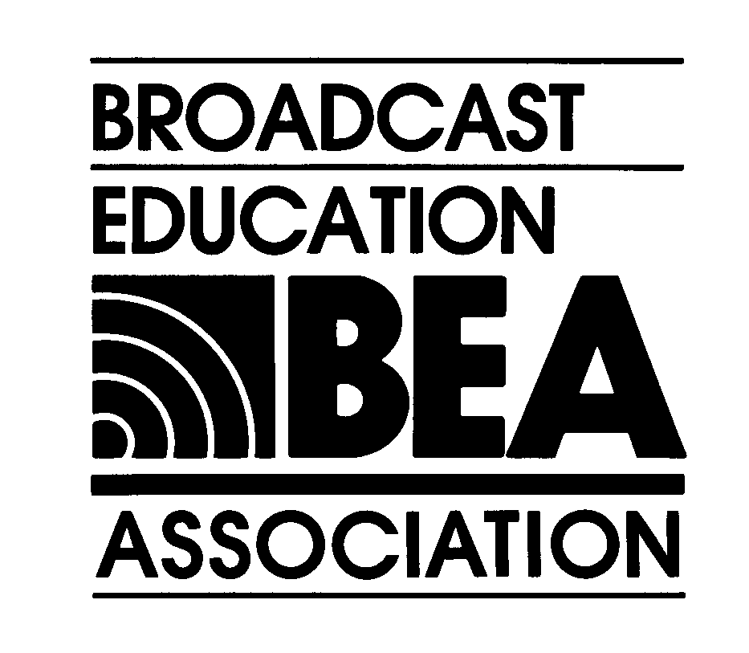

April 16 – 18, 2004

BEA 49th ANNUAL CONVENTION, Las Vegas, Nevada

CONTRACT AND INSERTION ORDER

Date: _________________________ P.O. #: ____________________

To: Broadcast Education Association Attention: Vivian Cohen
1771 N Street, NW Telephone: 240-243-2240 or 1-888-380-7222
Washington, DC 20036-2891 Fax: 301-869-8608
USA E-mail: vivian@datamaxsol.com
Web: www.beaweb.org
Please Respond Promptly.
EXHIBIT AND ADVERTISING SPACE RESERVATION DUE: February 17, 2004.
Advertising copy, Audio-Visual, Food and Beverage, and Signage Orders due February 20, 2004
Convention related orders must be sent with full payment. The deadline for payment is Friday, February 17, 2004, COB, ET. BEA will not go to print with an advertisement or plan to place an exhibitor or announce a sponsor unless the order is placed with full payment. Thank you.

Please mark your selections below

Program Advertising |  | Exhibits |  | Sponsorships
__$300, Full Page Ad  __$200, Half Page Ad  __$800, Cover 2  __$800, Cover 3  __$1,000, Cover 4  __$300, Inserts |  | __$1,000, 22’x10’ Booth  (3 tables)  __$800, 18’x10’ Booth  (2 tables)  __$600, 10’x10’ Booth  (1 table) |  | __$800, Coffee Break  __$400, Cookies with coffee break  __$3,000, Opening Continental Breakfast  __$10,000, Opening Night Reception  __$25,000, Premier Audio Visual Campaign
__$50, Institutional Mail List
__$100, Individual Mail List
__$100, Premium Placement (ex: opposite Cover 2, 3, Welcome page)

Sub Total: $_______________ $_________________ $________________________

TOTAL AMOUNT OWED: $________________________________________

Please complete the information below and return with your payment:

Contact Name:_________________________________________________________________________________

Company Name:________________________________________________________________________________

Address:______________________________________________________________________________________

City, State, Zip:_________________________________________________________________________________

Phone:___________________________Fax:__________________________Email:__________________________

METHOD OF PAYMENT: (please check one) ___Check enclosed, #__________ ____VISA ____MC ____AMEX

CC#:_____________________ Expiration Date:__________________ Name on Card:_________________________

Signature (required):_______________________________________________________________________________

RETURN THIS FORM, WITH PAYMENT, TO:

Broadcast Education Association, Dept. 6014, Washington, DC 20042-6014

If paying by credit card, you may fax this form to: 301-869-8608 or 202-775-2981 Thank you.
Visit: www.beaweb.org for all BEA 2004 convention information.

